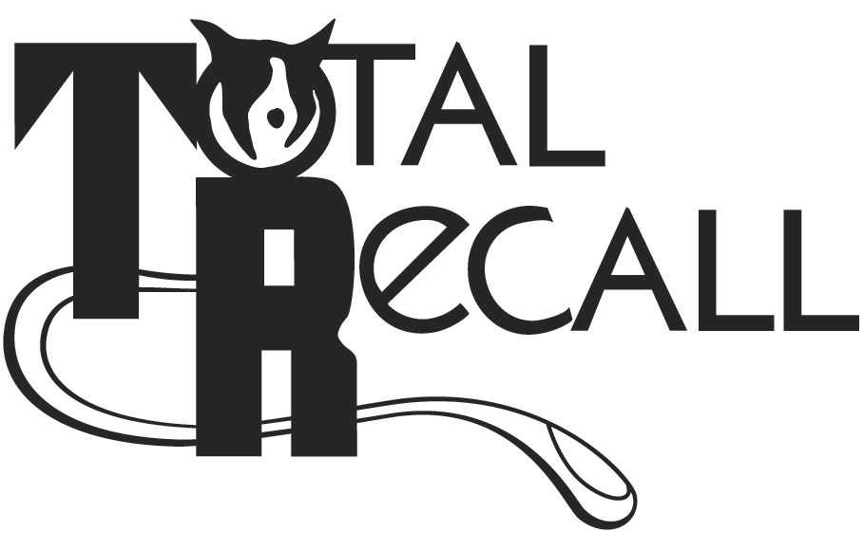
*SCHOOL LOCATION*
TOTAL RECALL SCHOOL FOR DOGS
17285 Forest Blvd. North (Hwy 61)
Hugo, MN 55038
651-464-1799 www.trdogs.com

MAILING ADDRESS:
Total Recall
9056 West Broadway
Forest Lake, MN 55025

CLASS REGISTRATION FORM

Name of Class Number of Weeks
Class Start Date Class Start Time
Name
Address
City State Zip County
Phone Email Address
Dog’s Call Name Breed Sex: M F
Age of Dog Date of Shots Spayed or Neutered? (circle one)
Has the dog bitten a person or other animal? Yes / No If yes, explain:

Has this dog had previous training? Y / N If yes, where?
How long has this dog been in training? Completed course? Yes / No

PAYMENT OPTIONS

We accept checks, Visa, Master Card, American Express & Discover (circle one). Class registration requires a non-refundable minimum deposit of $40.00 but you may choose to pay full amount.

Course Fee $ Deposit Amount $ Balance Due $
Card Number Exp. Date
Authorized Signature Amount to Charge $

Return signed registration with payment to mailing address listed above. Balance is due on the first night of class.

*****

Waiver and Assumption of Risk
(Please read carefully)

I understand that the rules presented by Total Recall School for Dogs are for the safety of all persons, dogs, and/or property while I am in attendance at Total Recall School for Dogs. In signing this Waiver and Assumption Risk I am accepting all responsibility for any and all actions by me, my dog, and any other persons I may bring that may result in injury to any persons, dogs, or property while at Total Recall School for Dogs.

I also agree to indemnify and hold harmless Total Recall School for Dogs, its owners and trainers from any and all claims by me, any member of my family, or guests who may accompany me, for any injury to said persons, dogs and/or property. I also agree to any other rules that may be brought to my attention, either in writing or verbally, in the future by Total Recall School for Dogs and its agents.

Owner’s Signature Handler’s Signature
(if different than owner)

